SOFTWARE ENGINEERING LAB
Twinkle Ghodki
23BCE1977

BCSE301L
Week - 1: Architectural Diagram and SRS

- ARCHITECTURAL DIAGRAM
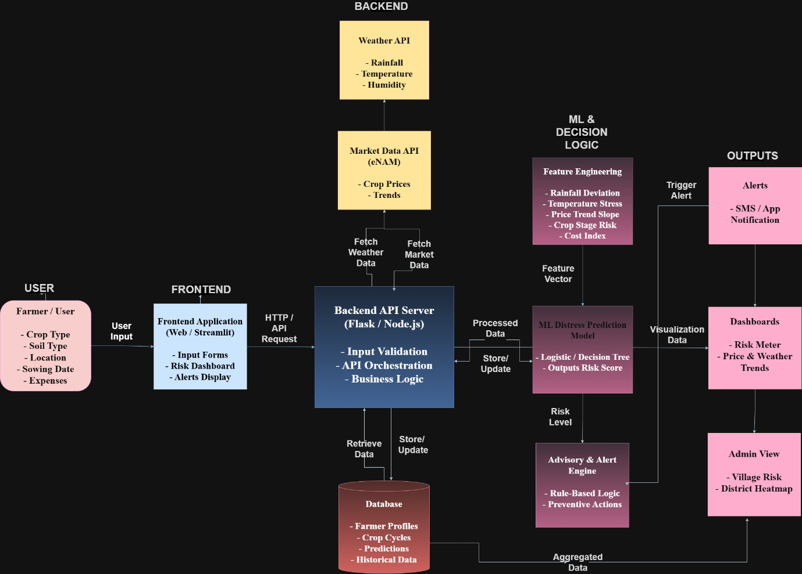

draw.io link –
https://app.diagrams.net/#G1E5MOauXQr4zPPFtreTj1eM6T6YfkhrL6#%7B%22pageId%22%3A%22Kel5LDxr8Jn0EgQ-L1-V%22%7D

- SOFTWARE REQUIREMENTS SPECIFICATION (SRS)
Project Title: AgriSOS – Early Farmer Distress Prediction and Advisory System

1. INTRODUCTION
1.1 Purpose
The purpose of SRS, here, is to define the software requirements of AgriSOS, a predictive decision-support system designed to identify early signs of farmer distress using real-time weather data, agricultural market trends, and farmer-provided inputs.
This SRS serves as a reference for system design, development, testing, and validation.

1.2 Scope
AgriSOS aims to:
- Collect crop, soil, and location details from farmers
- Integrate real-time weather and market price data
- Predict farmer distress risk using machine learning
- Generate actionable advisories and alerts
- Visualize risks through dashboards for farmers and administrators
The system focuses on early intervention, not post-crisis analysis.

1.3 Definitions, Acronyms, and Abbreviations
- Farmer Distress: Risk arising from adverse weather, crop failure, or market instability
- Risk Score: Numeric value representing probability of distress
- API: Application Programming Interface
- ML: Machine Learning
- eNAM: Electronic National Agriculture Market

2. OVERALL DESCRIPTION
2.1 Product Perspective
AgriSOS is a web-based application that follows a modular architecture consisting of:
- User interface layer
- Backend processing layer
- Data integration and storage layer
- Machine learning and decision logic layer
- Output and visualization layer
The system architecture follows a left-to-right data flow, where farmer inputs are processed through backend services and predictive models to generate alerts and dashboards.

2.2 Product Functions
- Accept farmer crop and field inputs
- Fetch weather and market price data via APIs
- Perform feature engineering
- Predict distress risk using ML models
- Generate advisory alerts
- Display dashboards and administrative views

2.3 User Classes and Characteristics
User Type | Description
Farmer | Provides crop data and receives alerts
Admin | Monitors aggregated risk at village/district level

2.4 Operating Environment
- Web browser (Chrome, Edge)
- Backend server (Flask / Node.js)
- Database (PostgreSQL / MongoDB)
- External APIs (Weather, Market)

2.5 Design and Implementation Constraints
- Depends on availability of public APIs
- Internet connectivity required
- Uses lightweight ML models for efficiency

3. SYSTEM ARCHITECTURE OVERVIEW
The AgriSOS system follows a multi-tier architecture consisting of:
- Frontend Application
- Backend API Server
- External Data Sources
- Feature Engineering & ML Modules
- Advisory & Alert Engine
- Database
- Output Interfaces (Alerts, Dashboards)
This architecture ensures separation of concerns and scalability.

4. SYSTEM FEATURES AND FUNCTIONAL REQUIREMENTS
4.1 Farmer Data Input Module
Description:
Allows farmers to enter agricultural details.
Functional Requirements:
- FR1: The system shall allow farmers to input crop type, soil type, location, sowing date, and expenses.
- FR2: The system shall validate all user inputs before processing.

4.2 Frontend Application Module
Description:
Acts as the primary user interaction layer.
Functional Requirements:
- FR3: The system shall display input forms for data entry.
- FR4: The system shall display alerts and dashboards.

4.3 Backend API Server Module
Description:
Handles business logic and system orchestration.
Functional Requirements:
- FR5: The backend shall process requests from the frontend.
- FR6: The backend shall coordinate data flow between APIs, database, and ML models.

4.4 External Data Integration Module
Description:
Fetches real-time environmental and economic data.
Functional Requirements:
- FR7: The system shall fetch weather data (rainfall, temperature, humidity).
- FR8: The system shall fetch crop price data from market APIs.

4.5 Feature Engineering Module
Description:
Transforms raw data into meaningful features.
Functional Requirements:
- FR9: The system shall calculate rainfall deviation.
- FR10: The system shall compute temperature stress.
- FR11: The system shall determine crop stage risk.
- FR12: The system shall compute price trend slope and cost index.

4.6 ML Distress Prediction Module
Description:
Predicts farmer distress risk.
Functional Requirements:
- FR13: The system shall generate a distress risk score.
- FR14: The system shall classify risk as Low, Medium, or High.

4.7 Advisory & Alert Engine
Description:
Generates preventive recommendations.
Functional Requirements:
- FR15: The system shall generate advisories based on risk level.
- FR16: The system shall trigger alerts when risk exceeds a threshold.

4.8 Dashboard and Admin Module
Description:
Provides visualization and monitoring.
Functional Requirements:
- FR17: The system shall display risk dashboards for farmers.
- FR18: The system shall provide village and district-level views for admins.

5. EXTERNAL INTERFACE REQUIREMENTS
5.1 User Interface
- Web-based UI
- Simple, icon-based layout
- Accessible via browser

5.2 Software Interfaces
- Weather API
- Market Data API (eNAM)
- Database interface

6. NON-FUNCTIONAL REQUIREMENTS
6.1 Performance
- System response time < 3 seconds
- Daily data refresh capability

6.2 Scalability
- Support multiple farmers concurrently
- Expandable to additional regions

6.3 Reliability
- Persistent storage of data
- Graceful handling of API failures

6.4 Security
- Role-based access control
- Secure API communication

7. DATA REQUIREMENTS
Stored Data
- Farmer profiles
- Crop cycles
- Risk predictions
- Historical trends

8. FUTURE SCOPE
- Integration with IoT sensors
- Satellite image analysis
- Mobile app version
- Government subsidy integration

9. CONCLUSION
AgriSOS provides a structured, data-driven approach to predicting farmer distress by combining real-time data, machine learning, and decision logic. The system is designed to be scalable, practical, and socially impactful, making it suitable for real-world agricultural decision support.

